
Sreenidhi Institute of Science and Technology
(An Autonomous Institution)
Regulations:
A14
Code No: 4DC01 Date:5-Dec-16(FN)
B. TECH. II-Year I-Semester Examinations, Nov/Dec 2016 (Supplementary)
DISCRETE STRUCTURES AND GRAPH THEORY (ECM)

Time: 3 Hours Max. Marks: 70
Note: a) No additional answer sheets will be provided.
b) All sub-parts of a question must be answered at one place only, otherwise it will not be valued.
c) Assume any missing data.

Part - A
Max.Marks:20

Answer all QUESTIONS. EACH QUESTION CARRIES 2 MARKS.
1. Construct the truth table for 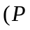 ˅ 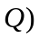 ˅ ¬ P
2. Eliminate the quantifier from the formula 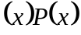 using the universe of discourse 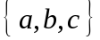
3. Define Lattice with an example
4. State generalized principle of inclusion and exclusion
5. Write any two properties of Fibonacci sequence of numbers
6. Explain planar graph
7. Using the statements R: Mark is Rich; H: Mark is Happy.
Write the following statements in symbolic form.
- Mark is poor but happy (ii) Mark is rich or unhappy
8. Define homomorphism of groups with an example
9. Define (i) Cut vertex (ii) Cut edge
10. In how many ways 5 gents and 4 ladies dine at a round table, if no two ladies are sitting
together

Part – B
Max.Marks:50

ANSWER ANY FIVE QUESTIONS. EACH QUESTION CARRIES 10 MARKS.

1. (a) Find the Principal disjunctive normal form of 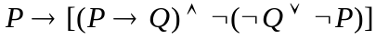
(b) Show that 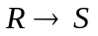 can be derived from the premises 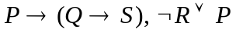 and 

2. (a) Show that
(b) Show that 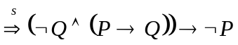 using automatic theorem proving

3. (a) Show that the set Z of integers is a monoid but not a group under operation such that
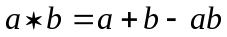
(b) Draw the Hasse Diagram of 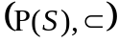 where 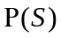 is the power set of 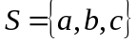
and ‘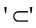 is the set inclusion

4. (a) What is the coefficient of 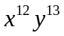in the expansion of 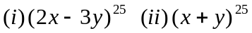
(b) How many integers between 1 and 250 are divisible by 2, 3, 5 or 7

5. (a) Solve the recurrence relation 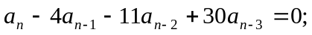
given that 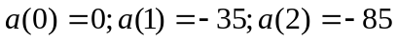
(b) Find the coefficient of 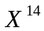 in (1+X+X ²+X ³)¹⁰

6. (a) Explain the BFS algorithm with an example
(b) If G is a connected plane graph, prove that 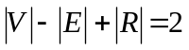

7. (a) Prove
(b) If R and S are equivalence relations on a set A, prove that 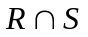is an equivalence relation

8. (a) Solve the recurrence relation 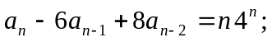 where, 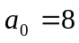 and 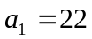
(b) Find the minimal spanning tree by Kruskal’s algorithm.

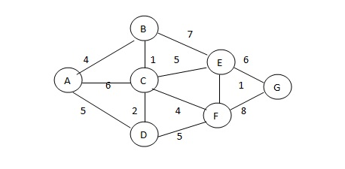

-- 00 -- 00 --

